**RIP VERSION 2**

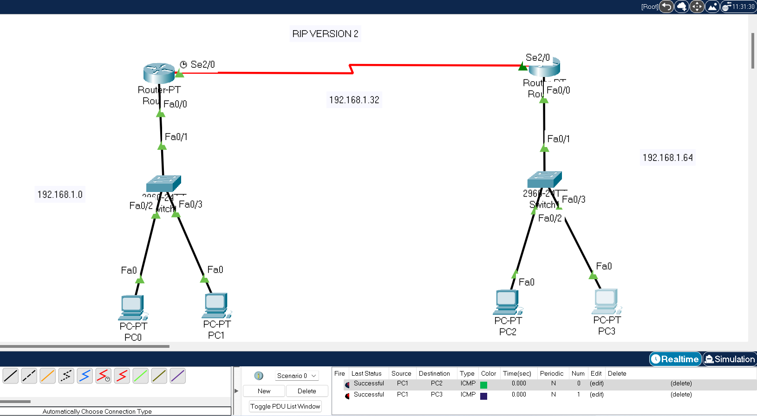

**ROUTER RO**

Router#en

Router#config t

Enter configuration commands, one per line. End with CNTL/Z.

Router(config)#router rip

Router(config-router)#version 2

Router(config-router)#network 192.168.1.0

Router(config-router)#network 192.168.1.32

Router(config-router)#exit

Router(config)#exit

Router#

%SYS-5-CONFIG_I: Configured from console by console

Router#copy running-config startup-config

Destination filename [startup-config]?

Building configuration...

[OK]

**ROUTER R1**

Router#en

Router#config t

Enter configuration commands, one per line. End with CNTL/Z.

Router(config)#router rip

Router(config-router)#version 2

Router(config-router)#network 192.168.1.32

Router(config-router)#network 192.168.1.64

Router(config-router)#exit

Router(config)#

Router(config)#exit

Router#

%SYS-5-CONFIG_I: Configured from console by console

Router#

Router#copy running-config startup-config

Destination filename [startup-config]?

Building configuration...

[OK]